Output and Variables Assignment

**Ques: How can you output “Physics” and “Wallah” in two different lines in C++?**

**Answer-**

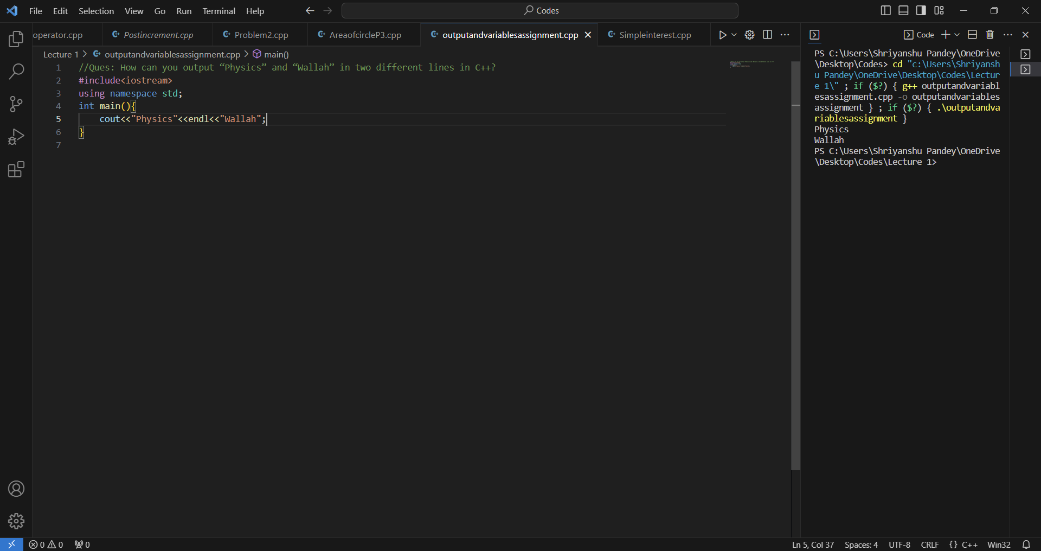

**Ques: Print 10 using 2 positive numbers less than 6  in C++ as output.**

**Answer-**

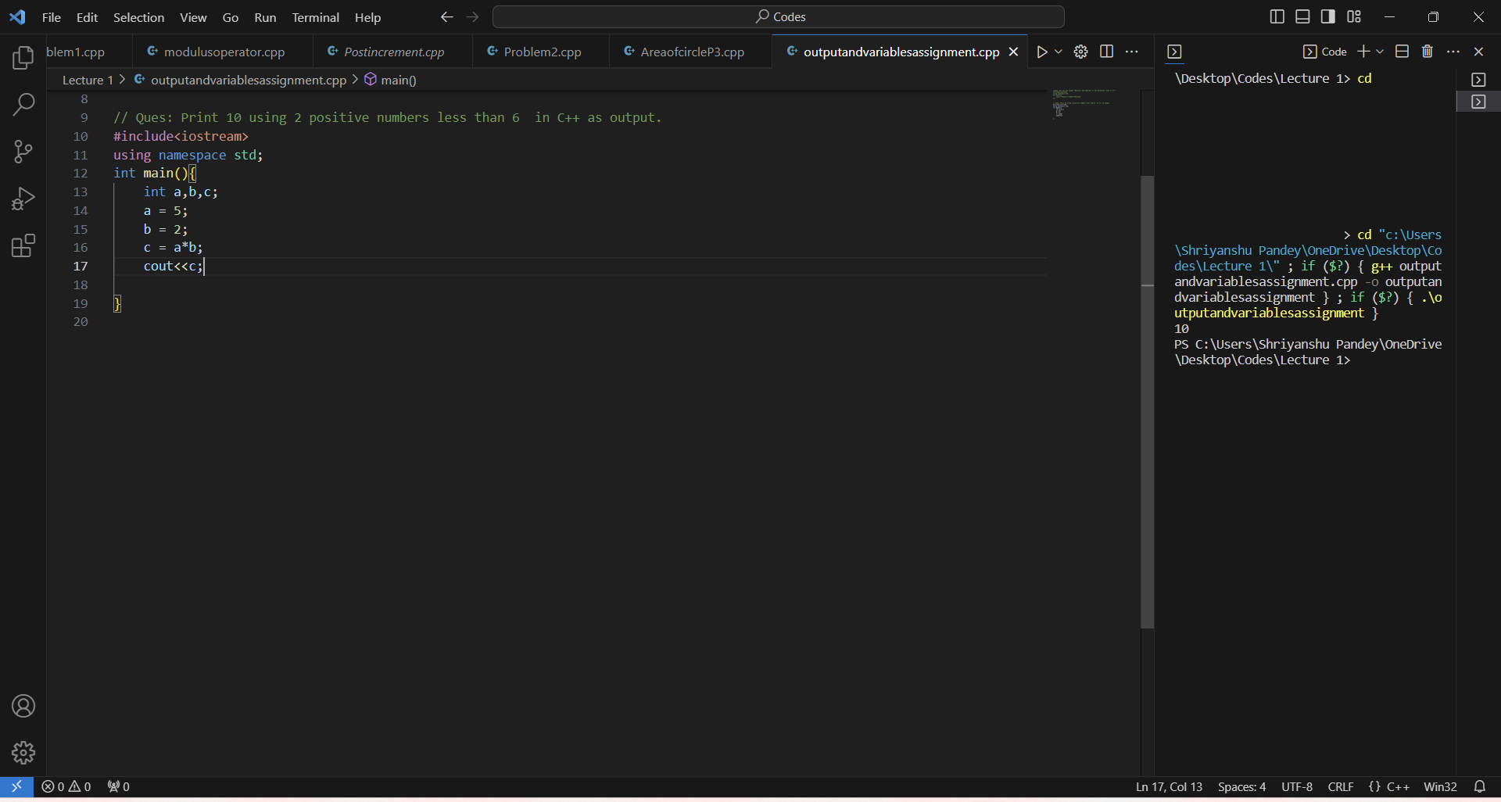

**Ques: How much space does following data types take ?**

1. **Int – 4 bytes**
2. **bool – 2 bytes**
3. **float – 4 bytes**

**Ques: What is the output of this program?**

**void main(){**

**int a=4;**

**int b=5;**

**a++;b--;**

**cout<<++a<<” “<<b–-;**

**}**

**Answer- Error**

**Ques: WAP to find the circumference of a circle with radius 10 in C++.**

**Answer-**

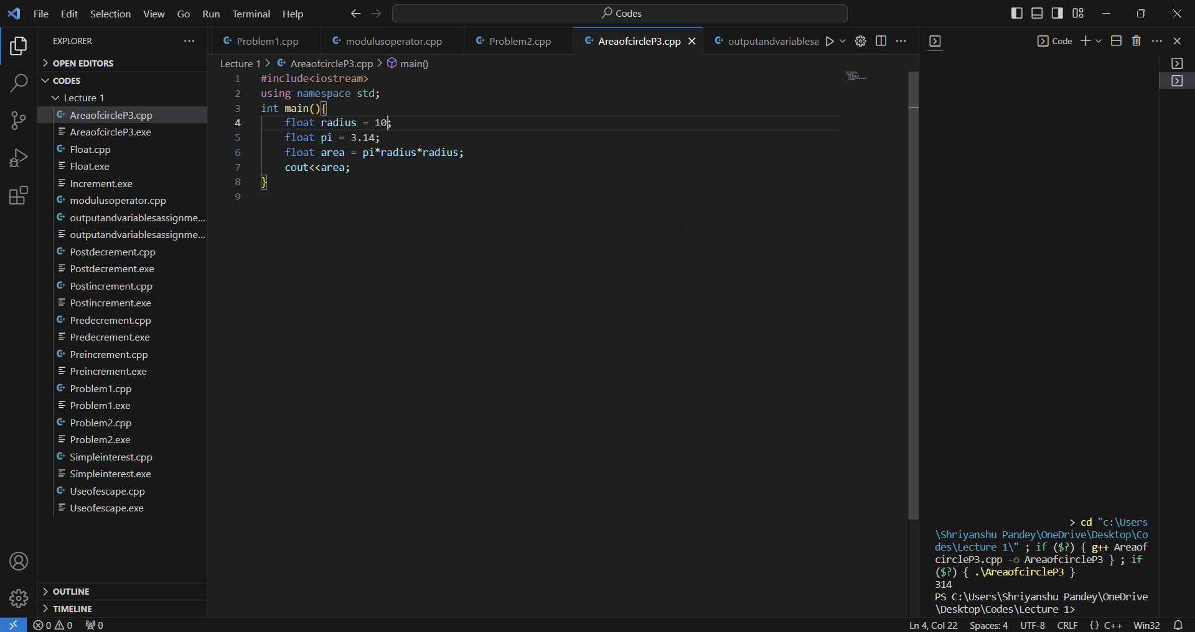

**Ques: How many of these can be a variable name?**

**Answer-**

**01PWskills - False**

**_FLOAT – True it is variable name**

**Int - False**

**FLOAT – True it is variable name**

**You will succeed - False**